2022-23 Report from the
Green Sanctuary Committee

Background
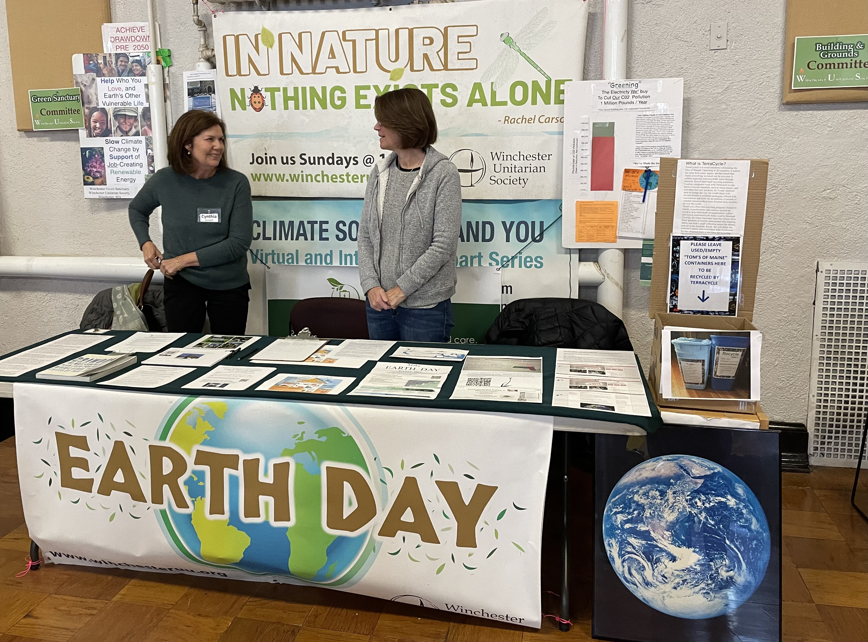
GS focuses on furthering the WUS's key goal of "environmental responsibility". GS meeting attendees and/or event workers this year were Maggie Russell, Lindy Brown, Fritzie Nace, Cynthia Randall, Rachel Whitehouse, Naomi Magnoni, and Co-Chairs Sue Doubler and Phil Coonley. Sheila Puffer was on sabbatical, but will be back next year. Alas, Maggie, a founding and most loyal member, is retiring. At the recent Sundae Sunday Committee Fair, four more adult members signed up for GS.

Historically, GS has focused on congregant and general public environmental education, and their actions to reduce individual carbon emissions and support wiser policy at the local (e.g. ending plastic bag use, promoting WinPower 100, and now management of gasoline leaf blowers), and state (e.g. especially the climate legislative agenda of UU MassAction and Mass 350). At the church building level, GS has led recycling, adoption by church of WinPower 100, and creation of a "WUS zero CO2" donation account. However, the Building and Grounds Committee (B&GC) led the church's solar array installation and other fossil fuel use reduction efforts. Within tight budget constraints, the B&GC made wise modest investments and leveraged MassSave incentives to achieve huge reductions in WUS church energy use and costs. Together B&GC and GS initiated our church's Mass Interfaith Power and Light (MIP&L) Environmental Stewardship Assessment, and have been following up on its many recommendations.

2022-23 GS Accomplishments
- Organized volunteer fall clean-up of WUS leaves without use of gasoline blowers. Assisted in spring weeding/edging/ mulching,
- Organized a 350 Mass MetroNorth createed "Stop and Steer the Money" zoom event for WUS, First Congo, and Epiphany congregants. Latest on which banks and credit cards to use is at bit.ly/39kCtao .Attended related Boston rallies at Chase Bank and at Bank of America.
- Supported the Repair Cafe held at First Congo.
- With SAOC, explored cooperation of environmental justice work and continued building a working relationship with Chelsea based environmental justice group GreenRoots Inc., Will soon begin monthly WednesdayWalks about Chelsea with GreenRoots staff and members.
- We supported Rachel Whitehouse & Woody Wood's "Quiet Clean Winchester" leaf blower on-going initiative.
- We attended the MIP&L Group meetings and collected related request for proposals (RFPs) and the resulting proposals.
- We obtained a proposal on owning the next generation WUS solar array with double our present annual production.
- We developed a net zero GHGs warrant (below) and its rationale; and committed to do our utmost to pass it at a 2023-24 congregational meeting:
Warrant: Given the urgency of the climate crisis, we the members of the WUS commit to achieving net zero carbon emissions* and total sustainability** in our building and congregational activities by May 2028.
- We urged the SC to fund the B&G C proposal to tighten the RE wing envelope and provide its heating and cooling by heat pumps ASAP. However we urged delay of a final decision on the use of above ground vs. geothermal/in-ground heat pumps until considering both the potential need for the system’s capacity to heat and cool both church buildings, and the church’s unusual river gravel geological site.

